Preview Text
BEYOND THE FEATURES
In this section, we look Beyond the Features to explore the three main forces shaping the modern Gen Z sanctuary: how we use the digital world to plan our future, why sustainable design is a moral choice, and the hard financial realities of living in the city. Dive into our supporting essays to gain the practical insights needed to turn your anxiety about identity, money, and environment into a clear blueprint for peace.

A. Information Design & Autonomy
Information Design & Autonomy
Information Design & Autonomy explores the digital landscape where the modern dream home is first conceived. This section analyzes how the architecture of online platforms gives Gen Z a crucial sense of control and self-definition, making the act of curating digital aesthetics an essential part of shaping their identity and future aspirations.
The Psychology of the Digital Mood Board
The Promise Pins
Everyone has been there. It’s midnight, the city noise is too loud, and one’s small apartment feels like it’s shrinking. So, people open Pinterest. They scroll through an endless feed of homes, minimalist concrete walls, and organized, professionally decorated offices. They tap 'Save,' 'Pin,' or 'Add to Collection.' They aren't just looking at decoration or designs, they are constructing a world that, right now, feels utterly unattainable.
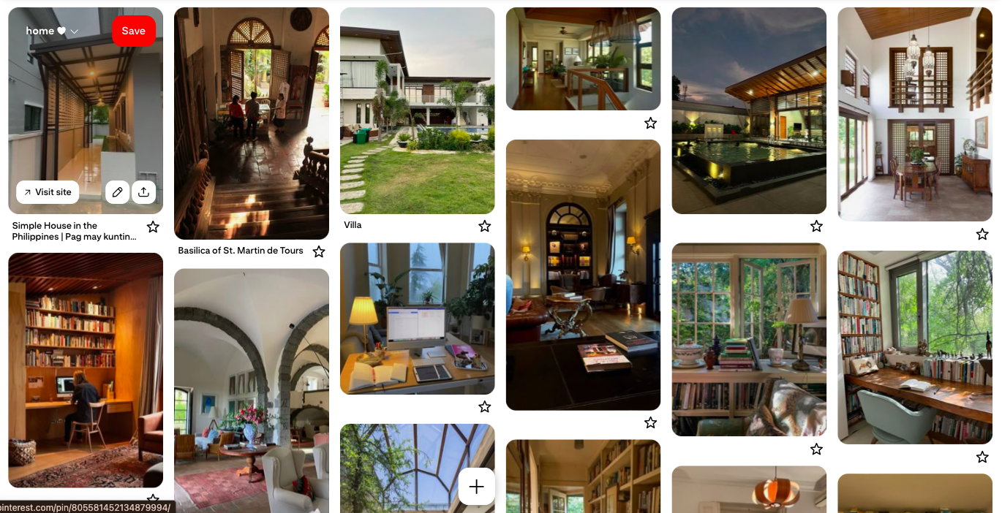
Example of a vision board in Pinterest
But what if that digital mood board, that collection of saved images on Instagram, that detailed Notion dashboard, or that secret board of Scandinavian furniture, isn't just a fantasy? What if it is, in fact, one of the most powerful, serious tools you possess for identity formation and achieving future stability?
These digital mood boards are people’s first piece of real estate.
It's the blueprint of their future self.

Curation as Control
In a hyper-urbanized environment like Metro Manila, Gen Z faces an overwhelming lack of control. You can’t control traffic, you can’t control rent prices, and you certainly can’t control how quickly you climb the career ladder. This immense, external pressure creates a deep psychological need for internal autonomy.
This is where the mood board steps in. It gives you immediate, low-stakes control over your entire aesthetic future.
Design experts Nada Endrissat, Gazi Islam, and Claus Noppeney describe the physical mood board's power in their research on design coordination, but the concept translates perfectly to the digital space. They found that these aesthetic objects, even when just visual, act as a coordination tool. They can direct and align independent actors (in your case, the disparate parts of your own life: your job, your saving habits, your aesthetic taste) while still maintaining creative freedom.

Your board isn’t just a collection of wishes, it’s a non-verbal contract with yourself, a balance between the dream life with the resources you currently have.

By constantly refining this digital blueprint, you are practicing decision-making. You are deciding: Do I prefer the curved chair or the straight one? Do I value natural light or high technology? These low-pressure choices are a dress rehearsal for the high-stakes decisions you will eventually make when you finally buy that first appliance or sign that first lease. It’s a way to train the brain to know what it truly wants, establishing a visual language that it can carry with it every day.
Value-tagging your goals
According to neuroscientist Dr. Tara Swart, as explained in a Medium piece by Sasha Pham, the simple act of looking at images on a vision board "primes the brain to grasp opportunities that may otherwise have gone unnoticed." This is because the brain employs a process called ‘value-tagging.’
Think of the brain as a hyper-efficient filter: it constantly prioritizes what’s important to your survival and goals, and filters out the rest. Dr. Swart notes that the brain assigns a higher ‘value’ to images than it does to plain written words on a to-do list. The more you look at those saved pins of the perfect office or the quiet bedroom, the more those images move up in value in people’s subconscious. They become critical data points.
This phenomenon is sometimes compared to the ‘Tetris Effect’: after playing the game for too long, people start seeing falling blocks in their everyday environment. Similarly, after repeatedly "seeing" their dream home on a screen, their brain starts noticing real-world opportunities, a sale on that specific texture of linen, a job opening that could fund that dream kitchen, or a small apartment listing with the exact window shape they pinned. The dream stops being an abstract fantasy and starts becoming a set of tangible clues.
From Pixel to Plan
Perhaps the most potent function of the digital mood board is its power to create self-efficacy and enhance self-definition.
For young professionals, especially those from underrepresented or low socioeconomic status (SES) backgrounds who face systemic barriers, the vision board serves as a crucial tool for aspirational growth. In Vision Boards and Adolescent Career Counseling: A Culturally Responsive Approach, researchers Waalkes, Gonzalez, and Brunson described vision boards as a "creative tool that counselors and clients can use to promote communication and identification of future goals" in a way that is strengths-based and solution-focused.
When financial or educational goals feel impossibly distant, the ability to visualize and articulate desired future space gives one a tangible sense of what they are fighting for. The board encourages:

Identity exploration  By designing your future home, you are deciding who you need to be to live there. | Enhances  self-efficacy  You stop thinking, "I can't afford that," and start thinking, "What are the specific, actionable steps I need to take to earn that?" | Develops your aspirations  It provides a clear, attractive target that motivates you to persevere through.

The digital mood board proves that people have the clarity, the taste, and the ambition to design a life of comfort and peace. It’s their declaration that they deserve a sanctuary for themselves.

So stop calling it a silly obsession. It is, in fact, the essential first step toward reclaiming autonomy in a world that tries to stifle potential.

B. Sustainable Living
Sustainable Living
Sustainable Living is about building a future that gives back. We explore the critical, often psychological, link between environmental responsibility and personal well-being, showing how small design and lifestyle choices can transform a mere dwelling into an ethical, nature-connected sanctuary in the midst of the concrete jungle.

Biophilia: Nature in the Concrete Jungle
The Need for Green
Living in the hyper-dense, often sensory-overloaded environment of Metro Manila, the pursuit of an ideal space often boils down to a single, essential need: peace. While we typically think of peace in financial or personal terms, science suggests a far deeper, more ancient longing is at work.
The term biophilia, coined by psychologist Erich Fromm in 1964, refers to people’s innate, evolutionary drive to connect with life and natural systems. Stemming from the Greek words for “life” and “love”, this concept explains why a walk through a forest or the sound of the ocean waves can instantly soothe and recenter us. When we cannot escape to nature, the solution is to bring nature into our refuge.
Architects and designers have formalized this need into biophilic design, which actively integrates nature into the built environment. As Stephen Kellert, a prominent advocate, wrote, this practice is crucial because it offers profound psychological benefits, including reduced stress and improved cognitive function. Biophilic spaces are not just aesthetically pleasing, they are fundamental to human well-being.
Kellert established six key elements of biophilic design that inform this practice:

Environmental Features
Direct connections to nature, such as using natural materials (wood, stone), ensuring access to sunlight, incorporating water features, and prioritizing well-ventilated spaces.

Natural Shapes and Forms

Incorporating the patterns and motifs found in nature, like the structure of a beehive, the curve of a tree, or the organic shape of leaves.

Natural Patterns and Processes

Focusing on variations and richness, such as the interplay of light and shadow, the way materials age and change over time, and focal points that offer visual contrast and complexity.

Light and Space

Using both natural light and filtered daylight, while also manipulating light to create reflective surfaces and visual shapes that bring movement to the space.

Place-Based Relationships

Linking the space to the local culture and ecology. This is why people feel a strong connection to local materials and geographical features, leading to the feeling of "homesickness" when away.

Evolved Human-Nature Relationships

Recreating the evolutionary benefits of nature, such as creating a sense of protection and refuge, or fostering feelings of awe and exploration, within the building's design.

Sanctuary Through the Senses
For Gen Z battling the intense pressures of adulthood and urban life, embracing biophilic design is a powerful, direct path to building your psychological sanctuary. The benefits of having this design aren’t abstract, it’s how you feel when you wake up each morning.
Natural light for a much happier day.
Sunlight is a critical regulator for your mood. When your space is flooded with natural light, you’re helping your body manage its own clock. Studies how exposure to daylight actually helps lower cortisol (that annoying stress hormone), making your apartment a place of true restoration instead of chronic anxiety.
Indoor plants clean the air (and the vibe).
They help filter the air in dense urban areas where quality is a concern, which immediately builds a sense of physical safety. But the very presence of life is also directly linked to lower stress and better focus. A little green goes a long way toward quietening the noise in your mind.
Natural textures ground us.
Have you ever noticed how calming it feels to touch raw wood or smooth stone? Materials like unfinished rattan, cozy linen, or exposed brick genuinely activate your senses. These natural textures act as grounding anchors that remind your system of the outdoors, helping to mute the relentless buzz of the city. The simplicity and warmth stand in stark contrast to the cold, impersonal structures of concrete, truly reinforcing your space as a refuge.

How can I apply this?
You don’t need a big budget or a huge space, you just need to be intentional.
1. Maximize vertical green space
Look up! If floor space is a luxury right now, start maximizing the vertical plane. Use hanging planters near windows or tiered shelves against walls. Every inch of vertical space you dedicate to greens is an inch that amplifies the biophilic benefits without eating up your limited floor area.


2. Passive cooling
Stop relying so heavily on expensive, energy-guzzling air conditioning. This is a crucial step towards both environmental and financial liberation. Focus on cross-ventilation, and ensure air can flow freely across the room. Use sheer curtains to filter harsh sun while maintaining air movement, and never block windows or vents with furniture.
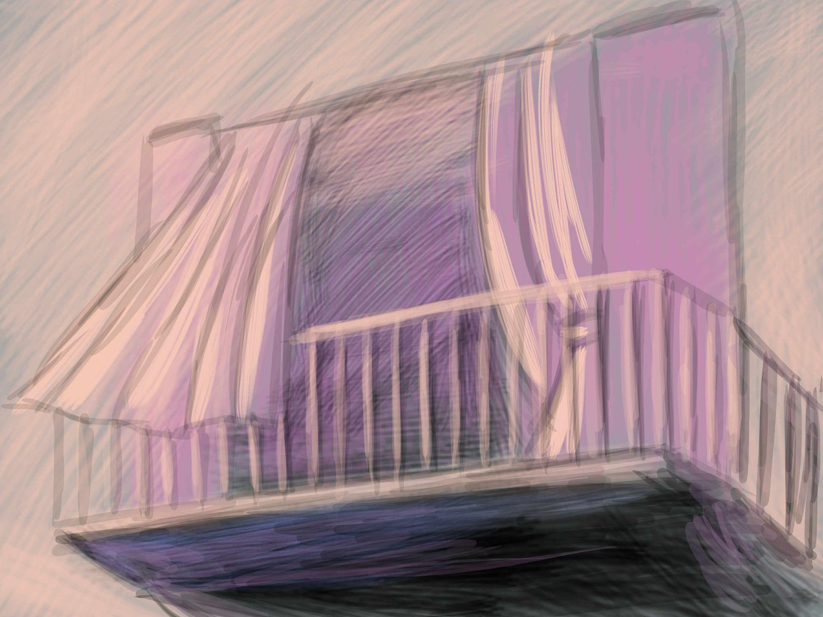

3. Choose air-purifying allies.
Invest in plants that pull double duty. Go for species like Snake Plants, Spider Plants, or Peace Lilies. Placing these in your work zone or bedroom gives you both beautiful aesthetics and a quantifiable improvement in the air quality of your personal space.
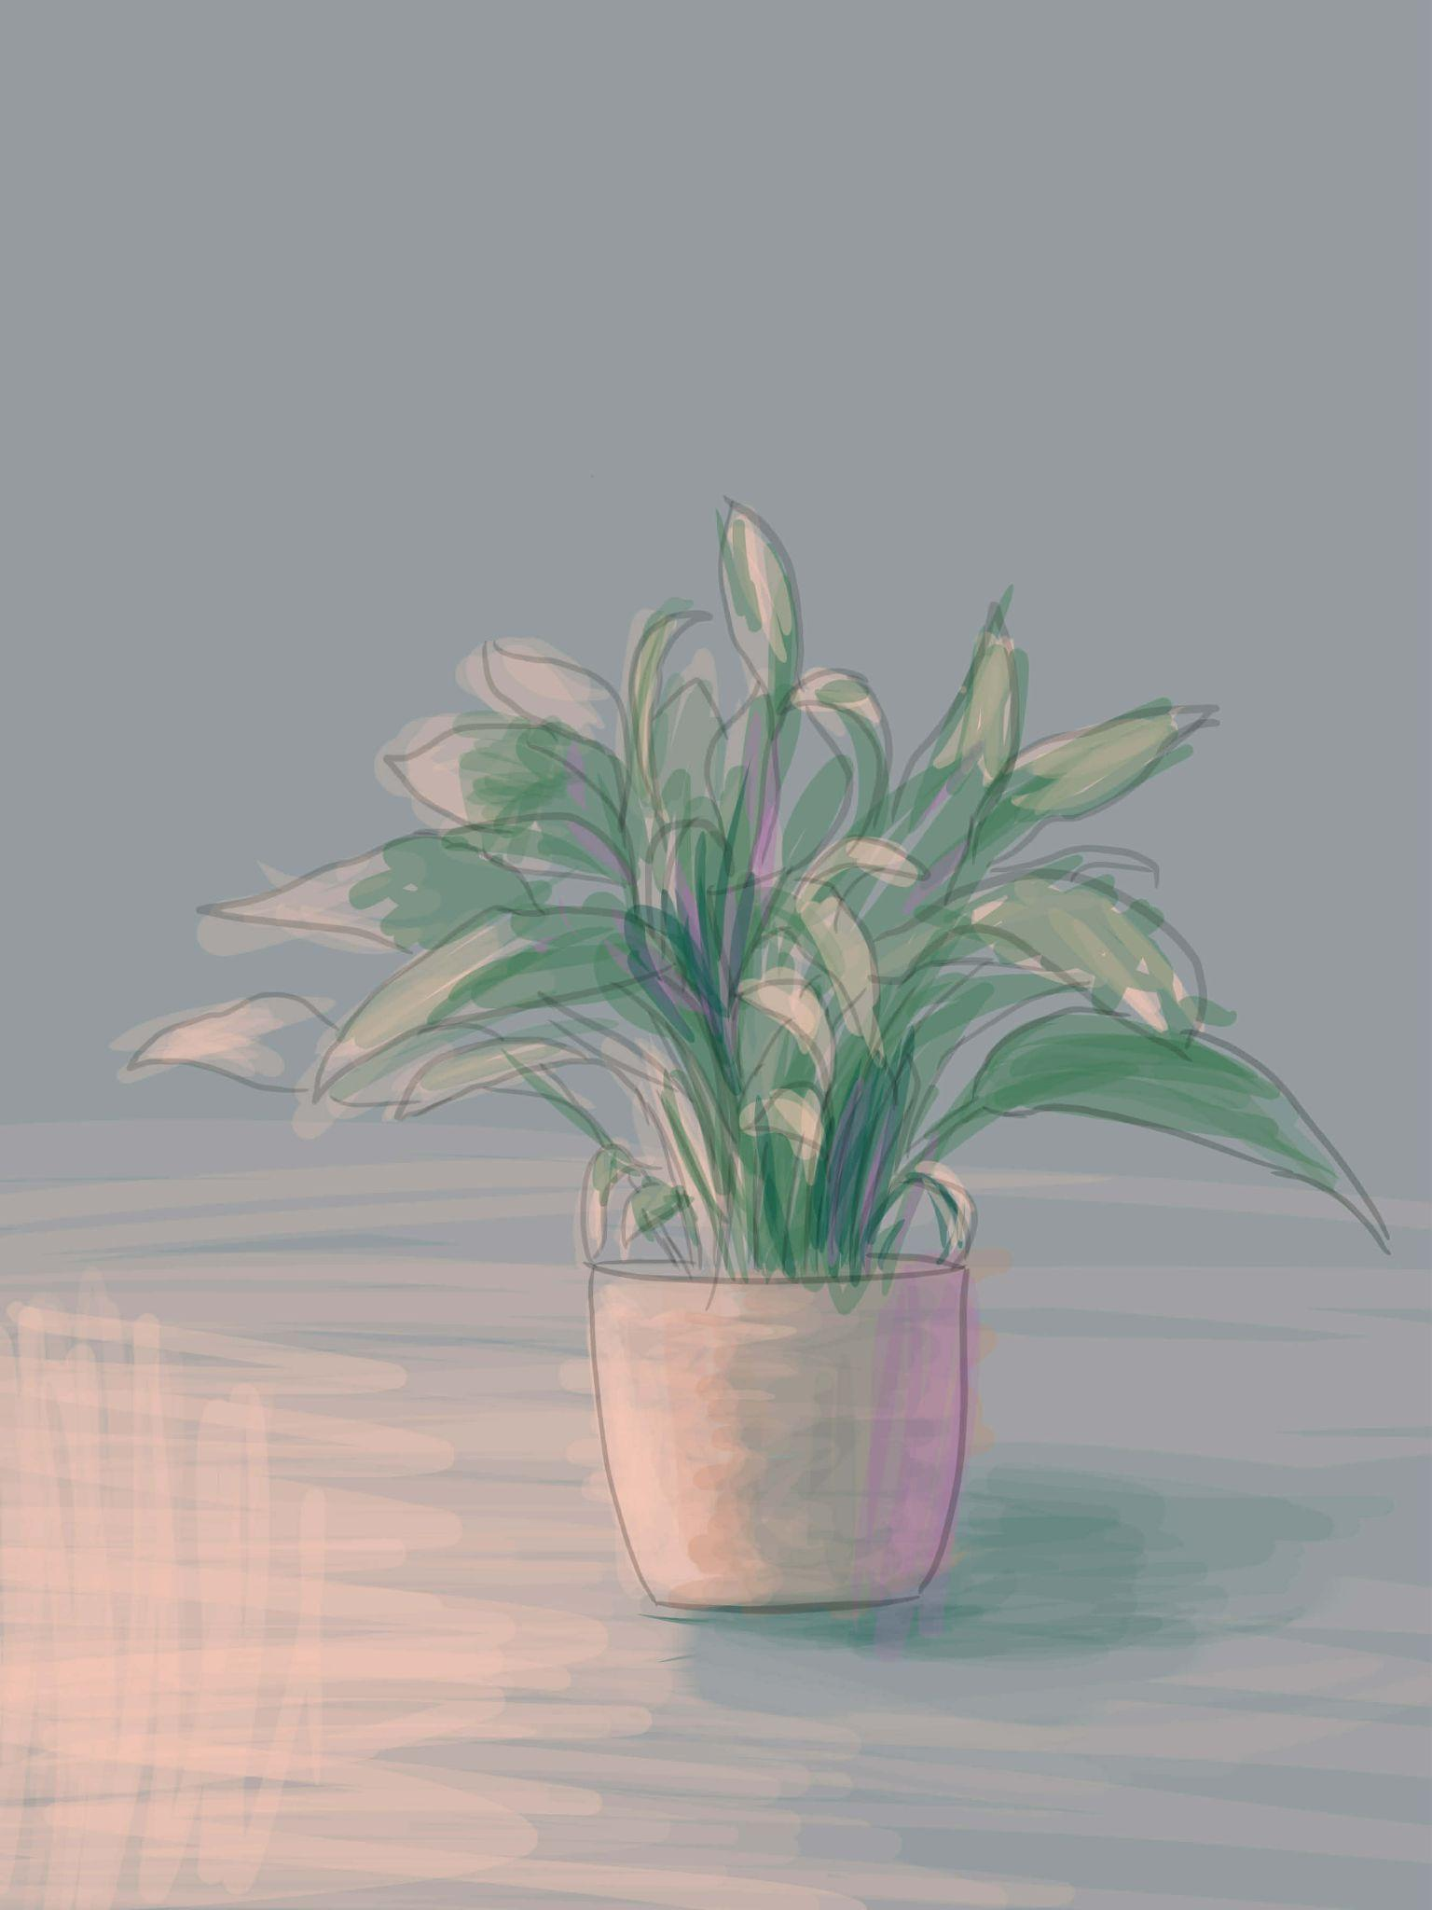
(Left; spider plants. Right; Peace Lilies)

4. Mirror the outdoors AKA trick the brain
Use reflective surfaces and mirrors, placing them strategically near light sources to bounce natural light deeper into the room. This technique mimics the dynamic movement of light in nature and creates an instant illusion of openness and spaciousness, which helps to fight that claustrophobic urban feeling.

5. Embrace imperfection
When choosing furniture or small accents, look for local, raw materials. The visible grain of wood or the texture of woven rattan brings the natural element indoors, connecting your sanctuary to the local environment and making your home feel authentic and ethically grounded.

C. Financial Liberation
Financial Liberation
Financial Liberation is the generation's survival strategy in one of the world's most competitive and costly urban centers. This section unpacks the financial anxiety of the urban struggle and explores how Gen Z is redefining value, prioritizing time, convenience, and psychological peace over expensive, traditional metrics of homeownership.

Rethinking Ownership: The Renting Mindset
For everyone’s entire life, everyone has heard one financial truth repeated at every family gathering: "Rent is wasted money." It’s a generational mantra, a belief that every peso spent on housing that one doesn’t own is money someone is simply throwing away.
But as people look at the cost of living in Metro Manila today, everyone realizes that for this generation, the generation starting out, that old belief has become a form of financial repression. They’re not throwing money away when they rent, they’re buying themselves time, flexibility, and genuine peace of mind.
The Weight of Tradition
The pressure to buy isn't just financial, it’s deeply cultural. In the Philippines, owning a home isn't just about having a house to live in, it's the ultimate measure of success, stability, and love for your family. It's the physical proof that you've "made it" and can provide a permanent legacy.
Generation Z constantly feels the weight of this tradition. Lolas (grandmother) and parents often talk about the security of lupa (land) and how renting means one will always be at the mercy of a landlord. When people choose to rent, they often feel like they have to justify their decision, explaining that they’re not being lazy or frivolous, but simply being realistic about the current economy.
This cultural pressure, while rooted in genuine care and a desire for stability, clashes violently with today’s prices. The down payment alone for a decent starter home or condo can wipe out years of savings, forcing most into crippling debt right when they need capital the most. People have realized that for many, the path to their "dream home" can't start with the anxiety of a massive, long-term loan.
People’s choice to embrace the renting mindset is their personal act of financial liberation. It's not the passive choice most parents imagine, it’s a proactive strategy to protect capital and mental health.

